Macey Center
Event Planning Checklist

Early Planning
- Determine the purpose of the event
- Consider size of the group, ages, and gender
- Designate a main contact individual for communicating with Macey Center
- Plan the event in advance to ensure the dates needed
- Begin a realistic budget for the event

Developing the Event
- Breakdown the event to day by day
- What time will your event start and end each day?
- Determine setup times required
- Estimate the number of people attending
- Review floor plans to determine which meeting areas you will need
- Decide on your seating needs
- What type of tables and chairs do you need?
- How many tables and chairs do you need?
- What arrangement do you want the room set up?
- Determine the audiovisual and production needs
- Which rooms will need sound equipment?
- What equipment do you need? Examples: Microphones, tv/vcr, podium, LCD projector, overhead projector.
- Make arrangements for food and beverages for each day of the event
- Where will you be eating?
- Finalize a menu for each meal
- How many people will be at each meal?
- Are there any dietary needs that you need to make arrangements for?
- Will you want bar service?
- Will you have break during the event with food and/or drinks?
- What time will the break be?
- Where will the food or drinks be placed?
- Review the contract with the event manager
  - Is the cost of the event still in your budget?
- Give the final numbers of people attending the event to Macey Center 7 days in advance
  - Review the details of the event with the event manager to make confirmations
After the Event
- Give feedback to the event manager on how the event went
- Review the invoice
- Payment is due 30 days after the invoice is sent
Appendix A

Seating Capacity Options

This chart shows the maximum seating capacity of the rooms and spaces where events occur.
Room | Banquet | Reception | Auditorium | Classroom | U-Shape | Square
Galena | 96 | 150 | 105 | 65 | 40 | 40
Copper | 96 | 150 | 105 | 65 | 40 | 40
½ Copper | 48 | 75 | 75 | 33 | 20 | 20
Upper Lobby | 175 | 300 | 150 | 100 | 50 | N/A
Lower Lobby | N/A | 175 | 50 | N/A | 18 | N/A
North Patio | 56 | N/A | N/A | N/A | N/A | N/A
Stage | 280-300 | 300 | 300 | 200 | 45 | 54
Amphitheater | 64 | N/A | N/A | N/A | N/A | N/A
Stage & Amphitheatre | 350 | 300 | 350 | 225 | N/A | N/A

Entrance Level Floor Plan
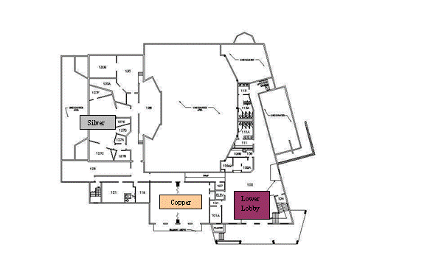
Upper Level Floor Plan
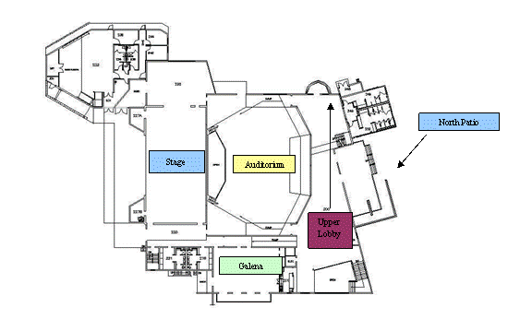

Appendix B

Seating Syles



